**In-memory enhancements and improvements in SQL Server 2016**

**In-Memory tables** were introduced in **SQL Server 2014** and were also known as **Hekaton tables**. I’ve written previously about In-memory tables for SQL Server 2014 and you can check in my **[**[**previous posts**](https://sqlwithmanoj.com/tag/hekaton/)**]** to know more about these type of tables with some Hands-on examples and demos.

**–>** In-memory tables as new concept in SQL Server 2014 had lot of limitations compared to normal tables. But with the new release of **SQL Server 2016** some limitations are addressed and other features have been added for In-Memory tables. These improvements will enable scaling to larger databases and higher throughput in order to support bigger workloads. And compared to previous version of SQL Server it will be easier to migrate your applications to and leverage the benefits of In-Memory OLTP with SQL Server 2016.

**–> I have collated all the major improvements here in the table below:**

[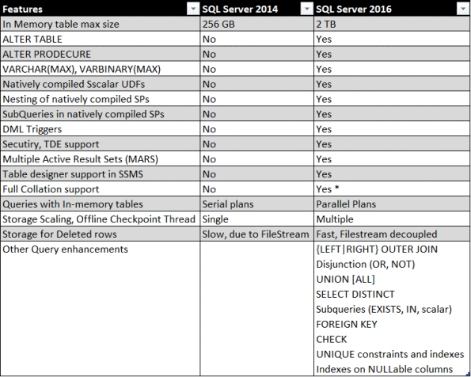](https://sqlwithmanoj.files.wordpress.com/2015/06/sql-server-2016-in-memory.png)

**\* Collation Support**  
1. Non-BIN2 collations in index key columns  
2. Non-Latin code pages for (var)char columns  
3. Non-BIN2 collations for comparison and sorting in native modules